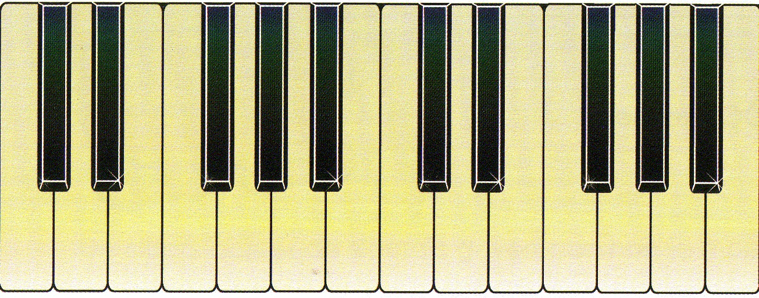

BES

AS

FIS

ES

DES

**1/2**

**1/2**

**1/2**

**1/2**

**1/2**

**1/2**

**1/2**

**1/2**

**1/2**

**1/2**

**1/2**

**1/2**

1 2 3 4 5 6 7 8

C D E F G A B C

**1**

**1**

**1**

**1**

**1**

C – C = Unison  
C – D = 2nd  
C – E = 3rd  
C – F = 4th  
C – G = 5th  
C – A = 6th  
C – B = 7th  
C – C = Octave

molAlways write down:  
1 2 3 4 5 6 7 8 So then P4 will be F for example  
C D E F G A B C Leave the Major and Perfects and add a mol to Minor  
 This means that m2= D and M2 = D

0 – **P1** – Unison (C – C) M(ajor) and m(inor)  
½ - m2 (C – DES)  
1 – M2 (C – D)  
1 ½ - m3 (C – ES)  
2 – M3 (C – E)  
2 ½ - **P4** (C – F)3 – Aug 4 (C – FIS)  
3 ½ - **P5** (C – G)4 – m6 (C – AS)  
4 ½ - M6 (C – A)  
5 – m7 (C – BES)  
5 ½ - M7 (C – B)  
6 – P8 (C – C)