Geography – Chapter 2 – The Earth’s crust as an archive

**Paragraph 2:**

* The Earth is the only planet with liquid water.
* In the **universe** there are many **stars**, like our sun. **Planets** rotate around these stars. Planets close to the star are made from solid rock. Others from gas.
* Other stars are very far away and their light takes millions of years to reach us. Our sun’s light takes about 8 minutes to reach us.
* Sun, Mercury, Venus, Earth, Mars, Jupiter, Saturn, Uranus, Neptune.
* The Earth looks like Venus and Mars. It has the same size and are relatively close to the sun. Yet life is only possible on Earth. The ocean floor is very heavy and consists of **Basalt**. That’s why the ocean floor is 4000 m lower than the continental floor. The continental floor consists of **Granite** which is lighter. Venus and Mars mainly consist out of basalt.
* All rock that is made of the remains of plants and animals is referred to as **organic sedimentary rock**. These rocks consist of skeletons, compressed shells but also coal, brown coal and peat. In the time when these organisms lived, CO2 was absorbed from the atmosphere which changed its composition. Large amounts of CO2 are stored in the earth’s crust as a result of rock formation. That’s why we now think that the atmosphere used to consist mainly of CO2.
* We believe that our solar system was created by an enormous cloud of gas and dust. The sun was the first one in the cloud and later all the planets came. The Earth was created by rocks that clumped together. As the debris collided, the earth was warmed up to 5000 oC.
* In the beginning of Earth, everything was molten. Later the Earth started cooling down. There was a lot of volcanic activity. Water vapour and CO2 were released into the atmosphere. All the water vapour condensed and they became the ocean. Life became suitable for life.

**Paragraph 3:**

*Precambrian – 620 Million years ago:*   
- Continents were shaped differently and located elsewhere. There was more CO2 and less oxygen.  
- Due to no ozone layer, ultraviolet radiation reached the Earth and all organisms had to live in seas.   
- Not many fossils have been found from this period, since they didn’t have hard parts yet.

*Permian – 270 Million years ago:*- The Ocean was inhabited by a big variety of fish, molluscs and shellfish such as trilobites.   
- The land was inhabited by plants. Due to this, a lot of oxygen got into the atmosphere.  
- The land formed a super continent called Pangaea. Only the edges of Pangaea were influenced by the sea. The rest of the land had a dry desert climate with raging winds.

*Cretaceous – 100 Million years ago:*- The continents weren’t physically connected.   
- Warmest era and sea level was 300 m higher than today.   
- A lot of animals lived in the seas such as ammonites.  
- The dinosaurs ruled the land.  
- There were plants with flowers too.

*Quaternary – 18 000 years ago:*- Continents reached their current positions  
- The Earth was covered in ice and the sea level was 100 m lower than nowadays.   
- We know that **mammoths** and sabre-tooth tigers could be found in this period because we found remains of them at the bottom of the North-sea and we found cave paintings from the people that lived then.

As you could see, the Earth and its continents changed continuously. When a continent collides with part of the ocean, the continent expands and mountains are formed.

**Paragraph 4:**

* Rocks and fossils in the earth’s crust provide a lot of information about the past, about how things used to look and about the climate at that time. E.g. a sandstone could be a petrified dune. If a remain of a dinosaur was found, it means that the dinosaur was covered in sand shortly after it died.
* 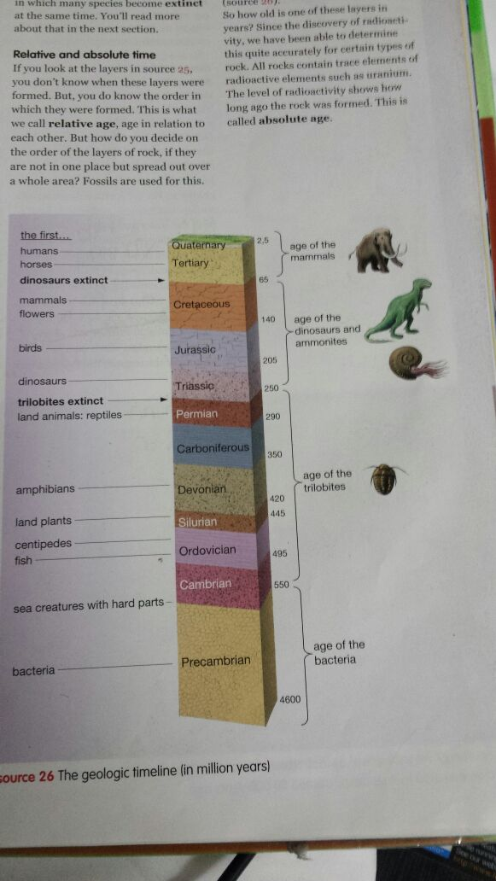**Sedimentary rock** takes millions of years to form. The lowest layer of this rock is oldest and so on. This rock was formed due to layers of sand and clay being deposited on top of each other. This rock can be found all over the world
* The new forms of life evolved in the following order: molluscs, shellfish, fish, land plants, reptiles and mammals. This development is called the **evolution of life**. Of course this is very slowly.
* On average, a species becomes **extinct** after about 23 Millions of years. Sometimes many species become extinct at the same time, due to for example volcanic activity.
* If you don’t know exactly when, but you do know the order, you’re speaking of **relative age**. If you have accuracy about when in time, if the age is measured in years, it’s called **absolute age**. To know when you can use fossils. Sometimes fossils have characteristics that can only be found in a certain period.

**Paragraph 5:**

* When a **meteorite** strikes a planet. It creates a **crater**. This happened on Earth 65 Millions of years ago. Rocks were turned into dust and they got into the atmosphere. This was the cause of a huge blackout
* The temperature rose to 1000 oC which caused animals and plants to be burned alive.
* The meteorite also caused the extinction of dinosaurs and ammonites.   
  Prove:  
  1. Iridium was found and this is normally only found in meteorites.  
  2. Rocks older than 65 million years ago contain dinosaur and ammonite fossils while younger rocks don’t.  
  3. There is a big crater which is dated back to 65 million years ago.
* Because of the extinction of dinosaurs. Mammals could evolve. They couldn’t earlier because dinosaurs were so dominant. The only mammal fossils were found in dinosaur excrements. This is why we do find mammal remains after 65 million years ago. With the dinosaurs gone, the mammals could evolve.
* The rock archives show that in geologic history many plant and animal species became extinct on more than one occasion.
* There are a couple of reasons why a big extinction could happen. Reasons like meteorite impacts, volcanic activity and climate and condition changes.
* You can also predict the future of the Earth. Within a couple of thousand years we will have another ice age. Every 25 million years there will be a period with increased volcanic activities, every 100 million years there will be a meteorite impact and over 500 million years the sun will become larger and warmer, which will be the end of the Earth and all the planets in our solar system.

**Paragraph 8:**

* The subsoil of the Netherlands is caused by the facts that we have moved across the planet and that we are slowly sinking.
* 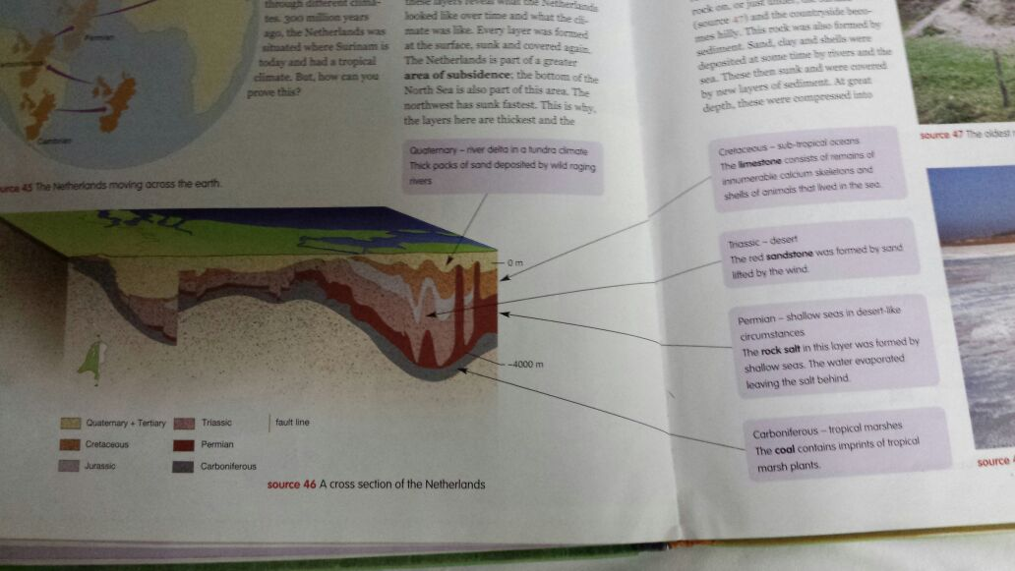The Netherlands was situated where Surinam is now and it had a tropical climate during the Cretaceous period.
* The Netherlands has been sinking for hundreds of millions of years and is being filed up at the same time by all manner of sediment from the rivers and the sea. This can be proved by looking at the layers. Every layer was formed at the surface, sunk and covered again. The Netherlands is part of a greater **area of subsidence.** On the picture you can also see **faults.**
* The largest part of the Netherlands is flat and consists of clay and sand. If you dig deeper you can see rock. Due to the pressure the sediment was turned into rock.

**Paragraph 9:**

* Beneath the surface of the Netherlands coal, natural, gas, **petroleum** and salt. These are **minerals.**
* Coal consists of petrified remains of plants and trees. It went like this: When a plant died, the remains were covered with water and therefore not decomposed. This formed peat. This was then covered and under great pressure and a high temperature, the peat turned into brown coal and then into coal. This is called **coalification.**
* In 1960, in the north of the Netherlands, natural gas was found. This gas was formed during the coalification of coal. Most gas escaped into the atmosphere but sometimes gas got trapped and remained in the ground.
* Rock salt was formed during the Permian age when the water in a shallow sea evaporated. Most salt layers are very deep down. However, in some areas, the salt is only a couple of metres under the surface. This is because salt is light and flexible. In some areas, it has been forced up by the weight of layers above pressing down. This is how salt domes have formed in the subsoil.
* There is less petroleum than natural gas in the ground. Petroleum consists of compressed micro-organisms that lived in the sea. Because the oil is light, impenetrable layers are required to prevent the oil from rising.
* In the search for minerals in the ground, **seismic soil research**  is carried out. A small earthquake is created which sends vibrations into the Earth. In a particular way geologists can determine the various layers in the Earth’s crust. With this you can tell if there are minerals present.
* Due to the extraction of natural gas and petroleum, the Netherlands Is even sinking faster. But you hardly notice this subsidence. Occasionally there’s a light earthquake.

**Paragraph 10:**

* Limestone is a useful mineral which doesn’t require you to dig deep for it. Limestone is mined in quarries, in **open-cast mining**.
* Due to the formation of the supercontinent Pangaea, many animals died out. Only reptiles could survive the desert climate. Later the conditions changed when Pangaea broke up. You can see that the Netherlands had a desert climate by the petrified dunes called red sandstone.
* Limestone is used to make cement, artificial fertiliser and road hardener. Also limestone was used to make chalk that we use to write at boards at school.
* During the Cretaceous period, the sea was hundreds of meters higher than it is today. At the bottom of this warm sea, a large amount of micro-organisms mounted up. These would later become the limestone of today.
* In the sea there lived a horrible monster with big sharp teeth. It was the mosasaur (mosasaurus). But this monster also died and ended up at the bottom of the sea. If you would find a mosasaur it would be an exception. But it provides you a rich harvest of **belemnites**, inner squid skeletons.
* The remains of a primitive bird were found in the area around Maastricht. Scientists have been discussing whether birds stem from dinosaurs for years. The specimen in Maastricht has a sharp beak and sharp teeth; this suggests a carnivorous predecessor to the dinosaur!