# Geo Chapter 01

## 2

The difference between the poor south and the rich north is called the **North-South divide.**

The causes are:

1. Development in MEDCs and LEDCs
2. The relationships between MEDCs and LEDCs

The division of labour and development in the south are influenced:

1. The Global Triad: US, Japan and EU
2. NICs: Taiwan, South Korea, Hong Kong and Singapore
3. Baby tigers: Malaysia, Thailand, the Philippines, Indonesia and Vietnam
4. BRIC countries: Brazil, Russia, India and China
5. Sub-Saharan Africa

The production is moving to other areas, because many trade barriers have disappeared, to low-wage economies. The MEDCs make the highest contributions, so they decide.

These are the goals made by the UN:

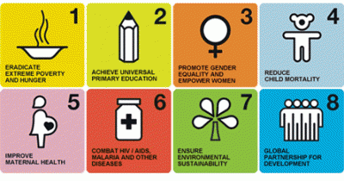

## 3

Because of the development, the north introduced things to avoid products from the south:

* Export subsidy
* Import restrictions

This is unfair trade. MNCs move to low-wage countries in order to produce things, with lower costs. The flying geese model shows that MNCs move to a place with low costs. If another country has even less costs, they will ‘fly’ to that one.

## 4

You have development aid and development cooperation. When a country has many debts, they will have a debt service. This is the percentage of the income used to pay debts. Example: Debt = 100 and GNP = 200, 50% debt service

When they only get more debts, they can go to the IMF to lend some money, but there are some agreements:

* Cut back in government expenditure
* Privatisation

The solution of unfair trade is called fair trade. In this way farmers in the south can get the same amount of money as a EU farmer would get.

## 7

There are 3 types of aid:

* Multilateral aid
* Bilateral aid
* NGOs

The Netherlands has almost 40 countries provided with aid, recipient countries. The donor darlings get most money.

Emergency aid is in case of an emergency, for short time, and structural aid on long term:

* Programme aid
* Project aid

And aid can be divided into:

* Tied aid, decide for yourself
* Untied aid

## 8

A joint venture is a company made by an existing company together with a former company or government from another country.

Globalisation can be divided into:

* Market-focused
* Cost-focused

Free trade zones are areas with low costs, but good infrastructure.

Corporate social responsibility is production with respect to human and environment.